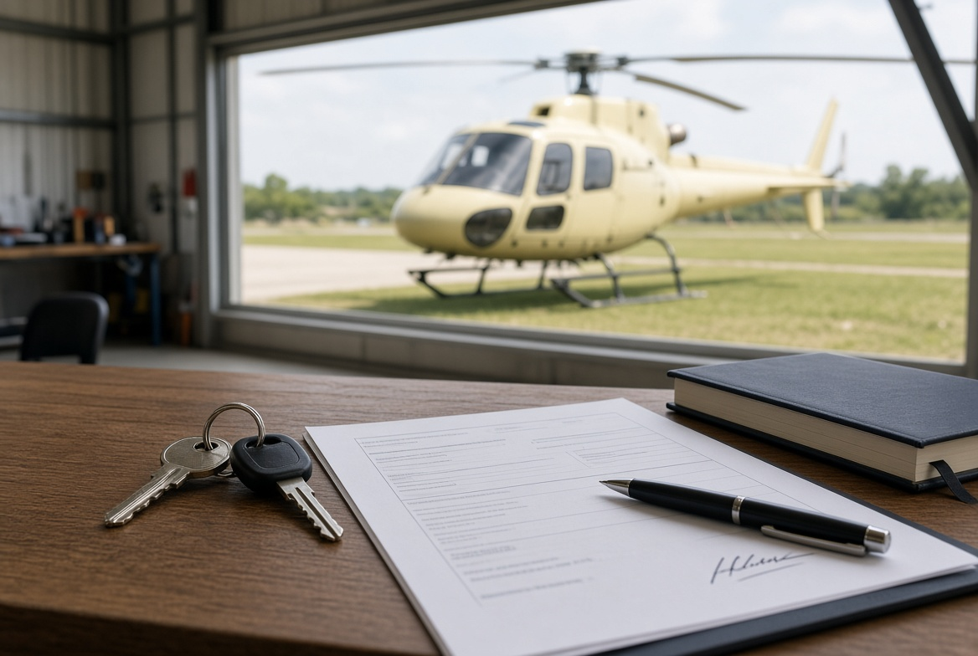
After the Purchase — Aircraft Handover Guide (Australia)
Once the remainder of the sale price is paid, the buyer collects the aircraft. Payment does not change the register by itself. This guide covers what must change hands that day, and how a VH- registration is transferred with CASA.
1. Who collects the aircraft
After the balance is paid, the buyer collects the aircraft. The seller does not keep it.
The agent can organise the day and hold copies of the paperwork. The agent cannot change the register unless both sides have asked them to lodge the forms.
2. What must go with the aircraft
Aircraft | The machine itself, in the condition agreed in the sales contract.
Keys and access | Keys, door locks, padlock codes.
Logbooks | Aircraft and engine logbooks. These stay with the aircraft. They are not posted and are not left with a workshop.
Component cards | Log cards for life-limited parts.
Current runout | Status of scheduled maintenance and component time.
Weight and balance | Current weight and balance data.
Flight manual | POH / flight manual for that aircraft.
Certificates | Airworthiness and release documents that belong to the aircraft.
Data plate | Stays on the airframe. It is not removed or posted.
3. What must be signed and given to the buyer
Signed sales agreement.
A short bill of sale or title wording in that agreement. CASA does not issue a bill of sale form. Title sits in the contract plus proof the deposit and remainder were paid.
Registration transfer for that country’s register.
Any lien release if there was finance on the aircraft.
4. What usually goes the same day
Covers, tie-downs, tools, and any spare equipment that was in the deal.
Avionics, radio, or ELT details if they were part of the sale.
Hangar notes or fuel arrangements only if they were included.
5. What the agent keeps
A copy of the signed sales agreement.
Proof the remainder was paid.
A record of paying the owner the deposit, less the commission already agreed with the owner.
6. Do not hand over
Logbooks by post, or to a workshop “to hold”.
The data plate off the airframe.
Registration left in the seller’s name “to sort later”.
If the machine cannot fly or cannot be registered without it, it goes with the aircraft that day.
7. CASA registration — VH- aircraft
CASA does not have a bill of sale form. CASA only changes who is on the register. Use myCASA if you can.
Who | What to do
Seller | Notify CASA of the transfer within 14 days. This is Form 027 Part 1 — notice of transfer of ownership. It is usually done in myCASA.
Buyer | Apply to become the registration holder within 28 days. This is Form 027-2 — New aircraft owner to become registration holder. There is a CASA fee. If this is late, CASA can suspend the registration.
Transfer date | CASA treats this as the day the money cleared — for a bank transfer, when the funds landed.
Agent | Can prepare the paperwork and walk both sides through myCASA. Cannot lodge as owner.
Start here: casa.gov.au — Change, transfer or cancel aircraft registration.
8. Order on the day
1. Remainder of the sale price is received.
2. Seller starts the CASA transfer in myCASA (14-day clock).
3. Buyer completes Form 027-2 / myCASA (28-day clock).
4. Aircraft, keys, and logbooks go to the buyer.
5. Agent pays the owner the deposit less the agreed commission.
Important notes
This is a practical guide. It is not legal advice and it is not a contract of sale.
Use a separate sales agreement for the price, inspection result, delivery, and transfer of ownership.
CASA forms and fees change. Check myCASA and the CASA aircraft registration pages before you lodge.

