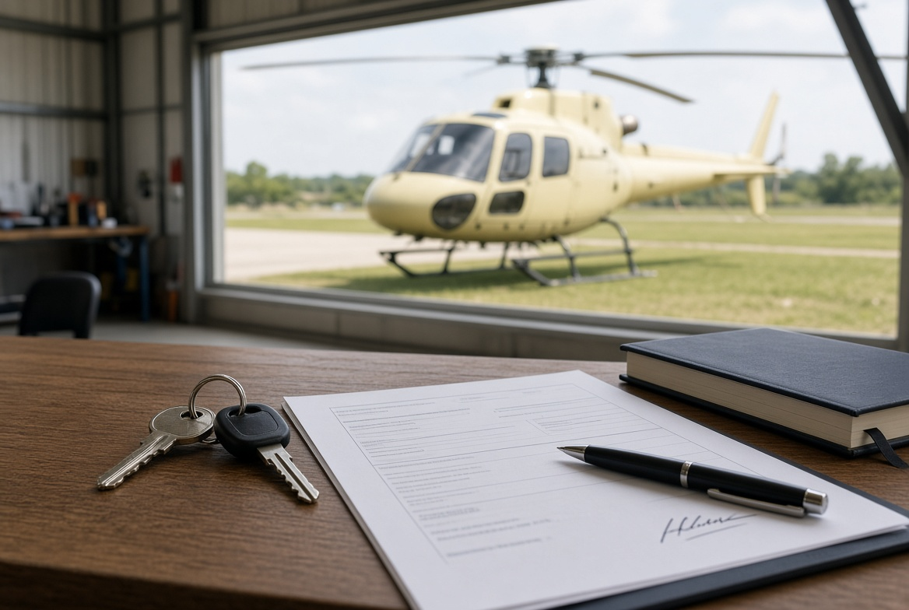
After the Purchase — Aircraft Handover Guide (Canada)
Once the remainder of the sale price is paid, the buyer collects the aircraft. Payment does not keep the old Canadian certificate of registration alive. This guide covers what must change hands that day, and how a Canadian-registered aircraft is transferred with Transport Canada.
1. Who collects the aircraft
After the balance is paid, the buyer collects the aircraft. The seller does not keep it.
The agent can organise the day and hold copies of the paperwork. The agent cannot change the register unless both sides have asked them to lodge the forms.
2. What must go with the aircraft
Aircraft | The machine itself, in the condition agreed in the sales contract.
Keys and access | Keys, door locks, padlock codes.
Logbooks | Aircraft and engine logbooks. These stay with the aircraft. They are not posted and are not left with a workshop.
Component cards | Log cards for life-limited parts.
Current runout | Status of scheduled maintenance and component time.
Weight and balance | Current weight and balance data.
Flight manual | POH / flight manual for that aircraft.
Certificates | Airworthiness and release documents that belong to the aircraft.
Data plate | Stays on the airframe. It is not removed or posted.
Interim certificate | The blank interim certificate of registration that came with the seller’s certificate. The buyer needs this if they want to fly before the new certificate arrives.
3. What must be signed and given to the buyer
Signed sales agreement.
Proof of custody and control. Transport Canada usually accepts a bill of sale. There is an optional template in Advisory Circular 202-002. It does not have to be notarized. It should identify the aircraft, say it is sold or transferred, name the new owner, and be dated and signed.
The blank interim certificate of registration from the seller.
Any lien release if there was finance on the aircraft.
4. What usually goes the same day
Covers, tie-downs, tools, and any spare equipment that was in the deal.
Avionics, radio, or ELT details if they were part of the sale.
Hangar notes or fuel arrangements only if they were included.
5. What the agent keeps
A copy of the signed sales agreement.
Proof the remainder was paid.
A record of paying the owner the deposit, less the commission already agreed with the owner.
6. Do not hand over
Logbooks by post, or to a workshop “to hold”.
The data plate off the airframe.
Registration left in the seller’s name “to sort later”.
If the machine cannot fly or cannot be registered without it, it goes with the aircraft that day.
7. Transport Canada registration — C-registered aircraft
A Canadian certificate of registration is not a title document. It shows who has legal custody and control. When custody and control change, the old certificate is cancelled automatically. The aircraft cannot be flown until the buyer has a new certificate or an activated interim certificate.
Transport Canada accepts a bill of sale as proof of custody and control. It does not use an FAA-style numbered bill of sale as the only official form.
Who | What to do
Seller | Notify Transport Canada of the transfer within 7 days, using myTC or Form 26-0519. Give the buyer the blank interim certificate. Notify the Canadian Beacon Registry if the aircraft has a 406 MHz ELT.
Buyer | Apply for a certificate of registration (Form 26-0522). Attach proof of custody and control (bill of sale) and a photo of the aircraft ID plate. Activate the interim certificate if they need to fly before the new certificate arrives.
Who can register | Usually a Canadian citizen or permanent resident aged 16 or over, or a Canadian entity that meets the ownership rules. Check Transport Canada if the buyer is not Canadian.
Agent | Can prepare the bill of sale and walk both sides through myTC. Cannot sign as owner.
Start here: tc.canada.ca — Transfer ownership (custody and control) of an aircraft. Also: Apply for a certificate of registration for an aircraft.
8. Order on the day
1. Remainder of the sale price is received.
2. Seller signs the bill of sale and gives the buyer the blank interim certificate.
3. Seller notifies Transport Canada within 7 days (Form 26-0519 / myTC).
4. Buyer applies for the new certificate of registration and, if flying, activates the interim certificate.
5. Canadian Beacon Registry is told about the ELT if there is one.
6. Aircraft, keys, and logbooks go to the buyer.
7. Agent pays the owner the deposit less the agreed commission.
Important notes
This is a practical guide. It is not legal advice and it is not a contract of sale.
Use a separate sales agreement for the price, inspection result, delivery, and transfer of ownership.
Transport Canada forms and fees change. Check tc.canada.ca before you lodge. This guide is for a Canadian-registered aircraft staying on the Canadian register.

