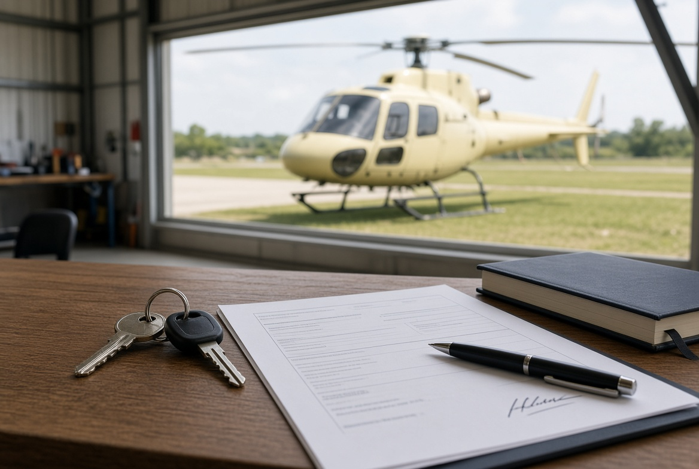
After the Purchase — Aircraft Handover Guide (Europe)
Once the remainder of the sale price is paid, the buyer collects the aircraft. Payment does not change the register by itself. Europe does not have one ownership register. EASA covers airworthiness. Each country keeps its own aircraft register. This guide covers what must change hands that day, and the usual national-register steps.
1. Who collects the aircraft
After the balance is paid, the buyer collects the aircraft. The seller does not keep it.
The agent can organise the day and hold copies of the paperwork. The agent cannot change the register unless both sides have asked them to lodge the forms.
2. What must go with the aircraft
Aircraft | The machine itself, in the condition agreed in the sales contract.
Keys and access | Keys, door locks, padlock codes.
Logbooks | Aircraft and engine logbooks. These stay with the aircraft. They are not posted and are not left with a workshop.
Component cards | Log cards for life-limited parts.
Current runout | Status of scheduled maintenance and component time.
Weight and balance | Current weight and balance data.
Flight manual | POH / flight manual for that aircraft.
Certificates | Airworthiness and release documents that belong to the aircraft.
Data plate | Stays on the airframe. It is not removed or posted.
3. What must be signed and given to the buyer
Signed sales agreement.
A bill of sale or other title deed. Many European authorities accept a bill of sale plus proof the price was paid. Some countries want the original or a certified copy. Some want a translation.
The current Certificate of Registration, to be returned to that country’s aviation authority.
Any lien release or mortgage discharge if there was finance on the aircraft.

4. What usually goes the same day
Covers, tie-downs, tools, and any spare equipment that was in the deal.
Avionics, radio, or ELT details if they were part of the sale.
Hangar notes or fuel arrangements only if they were included.
5. What the agent keeps
A copy of the signed sales agreement.
Proof the remainder was paid.
A record of paying the owner the deposit, less the commission already agreed with the owner.
6. Do not hand over
Logbooks by post, or to a workshop “to hold”.
The data plate off the airframe.
Registration left in the seller’s name “to sort later”.
If the machine cannot fly or cannot be registered without it, it goes with the aircraft that day.
7. Registration in Europe
EASA does not transfer ownership. The national civil aviation authority of the state of registry does that — for example DGAC/DSAC in France, LBA in Germany, AESA in Spain, ENAC in Italy, IAA in Ireland, Traficom in Finland.
If the aircraft stays on the same national register, the Certificate of Airworthiness and Airworthiness Review Certificate usually stay with the aircraft and are updated. If the aircraft moves to another country, it must be deregistered in the old state and registered in the new one. That is a different job to a same-country sale.
The United Kingdom is no longer in EASA. For a G-registered aircraft the buyer usually files form CA1 within 28 days. The seller returns the Certificate of Registration to the UK CAA (form CA71 if the certificate is not available).
Who | What to do
Seller | Signs the bill of sale / title deed. Returns the Certificate of Registration to the national authority. Notifies that authority of the change of owner as that country requires.
Buyer | Applies to become the new registration holder with that country’s CAA. Attaches the bill of sale and proof of payment if asked. Arranges insurance that meets Regulation (EC) 785/2004 where that applies. Pays the national fee.
Same country | Ownership changes on that register. Airworthiness documents usually travel with the aircraft.
New country | Old CAA deregisters. New CAA registers and issues a new Certificate of Registration. An Export Certificate of Airworthiness is often required.
Agent | Can prepare the file and check which CAA applies. Cannot sign as owner.
Always use the forms of the state of registry printed on the Certificate of Registration. Do not assume one European form covers every country.
8. Order on the day
1. Remainder of the sale price is received.
2. Seller signs the bill of sale and returns the Certificate of Registration to the national CAA.
3. Buyer files that country’s change-of-owner / registration application with the title papers.
4. Aircraft, keys, and logbooks go to the buyer.
5. Agent pays the owner the deposit less the agreed commission.

Important notes
This is a practical guide. It is not legal advice and it is not a contract of sale.
Use a separate sales agreement for the price, inspection result, delivery, and transfer of ownership.
National forms and fees change. Check the CAA of the state of registry before you lodge. This guide is a common pattern, not a substitute for that country’s process.

