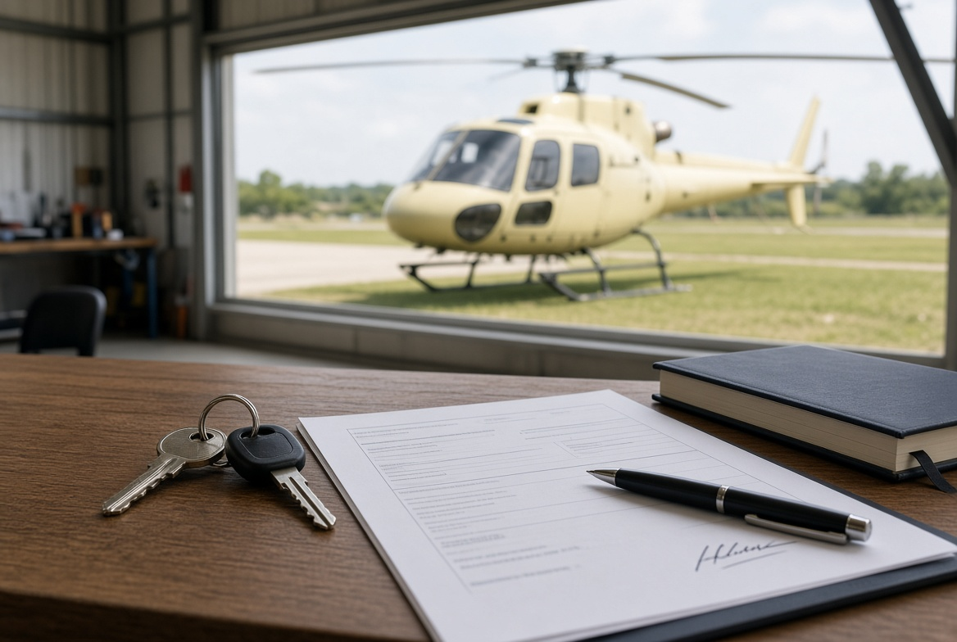
After the Purchase — Aircraft Handover Guide (United States)
Once the remainder of the sale price is paid, the buyer collects the aircraft. Payment does not change the FAA register by itself. This guide covers what must change hands that day, and how an N-number aircraft is transferred with the FAA.
1. Who collects the aircraft
After the balance is paid, the buyer collects the aircraft. The seller does not keep it.
The agent can organise the day and hold copies of the paperwork. The agent cannot change the register unless both sides have asked them to lodge the forms.
2. What must go with the aircraft
Aircraft | The machine itself, in the condition agreed in the sales contract.
Keys and access | Keys, door locks, padlock codes.
Logbooks | Aircraft and engine logbooks. These stay with the aircraft. They are not posted and are not left with a workshop.
Component cards | Log cards for life-limited parts.
Current runout | Status of scheduled maintenance and component time.
Weight and balance | Current weight and balance data.
Flight manual | POH / flight manual for that aircraft.
Certificates | Airworthiness and release documents that belong to the aircraft.
Data plate | Stays on the airframe. It is not removed or posted.
3. What must be signed and given to the buyer
Signed sales agreement.
FAA Form 8050-2 Aircraft Bill of Sale, signed by the seller. Make two originals. The seller’s name must match the current FAA registration exactly.
FAA Form 8050-1 Aircraft Registration Application, completed by the buyer.
Any lien release if there was finance on the aircraft. Check the FAA aircraft records for recorded liens before completion.

4. What usually goes the same day
Covers, tie-downs, tools, and any spare equipment that was in the deal.
Avionics, radio, or ELT details if they were part of the sale.
Hangar notes or fuel arrangements only if they were included.
5. What the agent keeps
A copy of the signed sales agreement.
Proof the remainder was paid.
A record of paying the owner the deposit, less the commission already agreed with the owner.
6. Do not hand over
Logbooks by post, or to a workshop “to hold”.
The data plate off the airframe.
Registration left in the seller’s name “to sort later”.
If the machine cannot fly or cannot be registered without it, it goes with the aircraft that day.
7. FAA registration — N-number aircraft
The United States does have an official bill of sale form. Title is transferred with FAA Form 8050-2. The buyer then applies to be the new registered owner with Form 8050-1. Both usually go to the FAA Civil Aviation Registry together.
Until the FAA processes the package, the seller can still appear on the federal record. That is why the forms should leave with the payment, not “sometime later”.
Who | What to do
Seller | Signs Form 8050-2 (Bill of Sale) in ink or with an accepted digital signature. Removes the old registration certificate from the aircraft, completes the sale information on the back, and sends it to the FAA Registry. Keeps a photocopy.
Buyer | Completes Form 8050-1. Pays the FAA registration fee (currently $5). Carries a copy of 8050-1 in the aircraft as temporary registration while the FAA processes the file. Processing often takes several weeks.
Both forms | Mail together to the FAA Civil Aviation Registry, Oklahoma City. The purchaser name on 8050-2 must match the applicant name on 8050-1.
Agent | Can prepare the forms and check the names match the register. Cannot sign as owner.
Start here: faa.gov — Aircraft Registration. Forms: AC Form 8050-2 (Bill of Sale) and AC Form 8050-1 (Registration Application).
8. Order on the day
1. Remainder of the sale price is received.
2. Seller signs Form 8050-2 and completes the back of the old registration certificate.
3. Buyer completes Form 8050-1 and keeps a copy in the aircraft.
4. Aircraft, keys, and logbooks go to the buyer.
5. Package is sent to the FAA Registry.
6. Agent pays the owner the deposit less the agreed commission.

Important notes
This is a practical guide. It is not legal advice and it is not a contract of sale.
Use a separate sales agreement for the price, inspection result, delivery, and transfer of ownership.
FAA forms and fees change. Check faa.gov before you lodge. This guide is for a U.S.-registered aircraft staying on the U.S. register.

